# 1 – 001

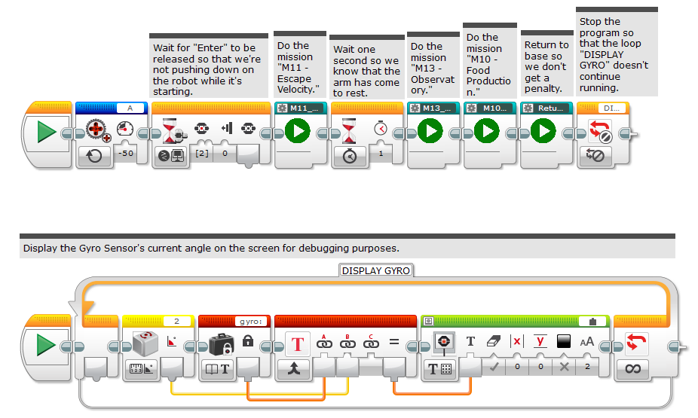

# 2 – M11_EscapeVelocity

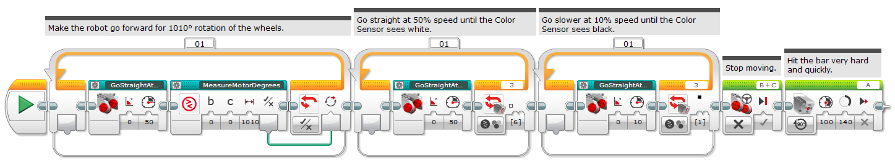

# 3 – M13_Observatory

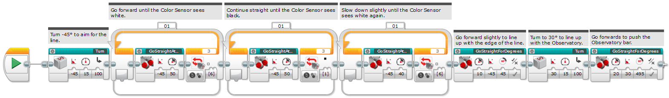

# 4 – M10_FoodProduction

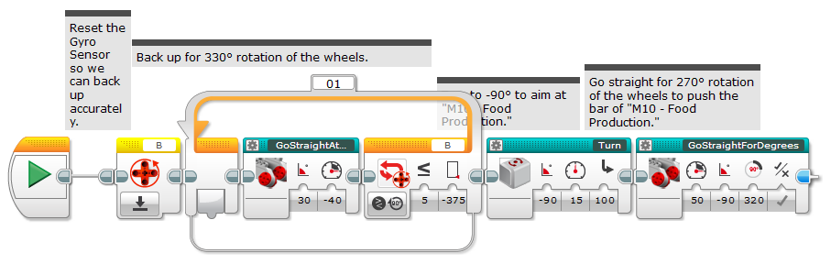

# 5 – ReturnToBase_M10_M00

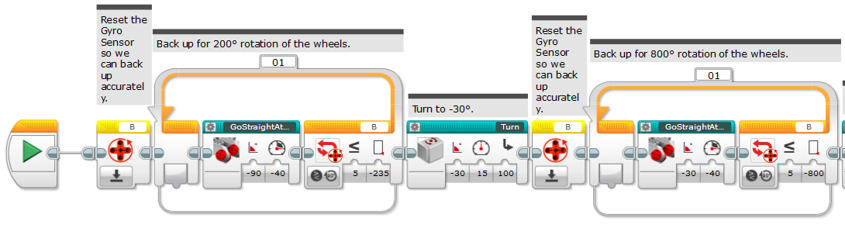

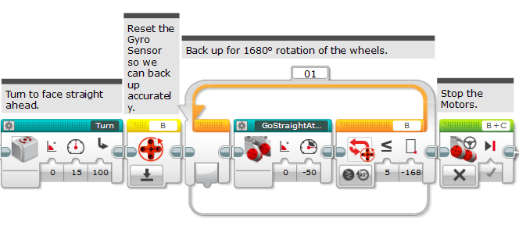

# 6 – M05_Extraction

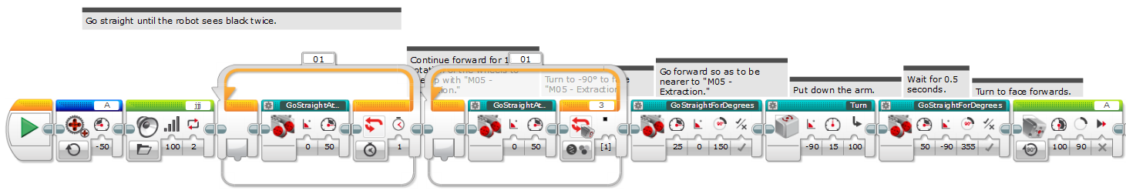

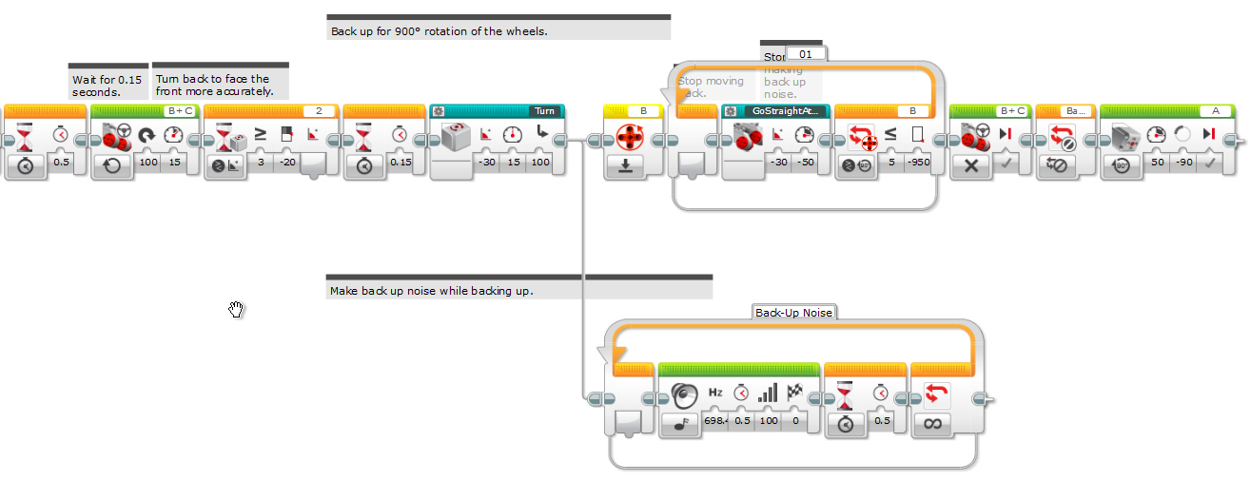

# 7 – Escape_Velocity_2

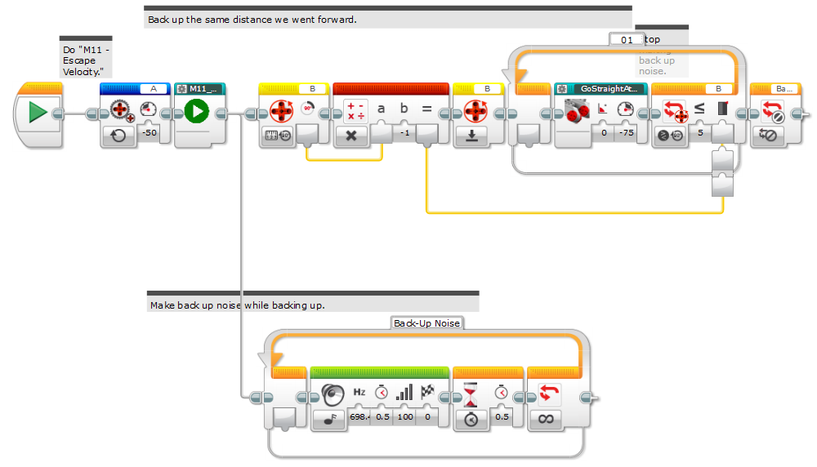

# 8 – M01_SpaceTravel

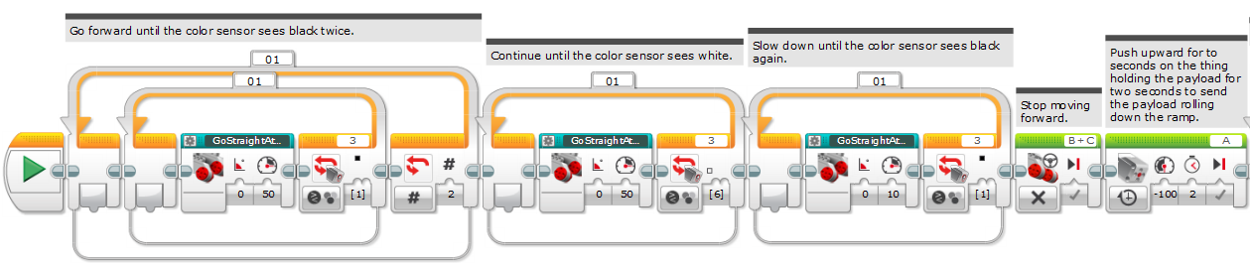

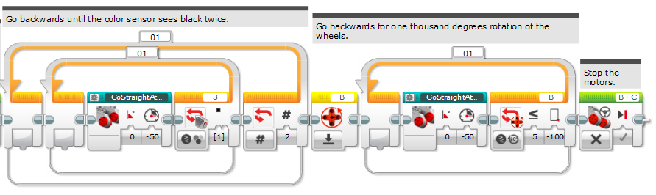

# 9 – Observatory_2

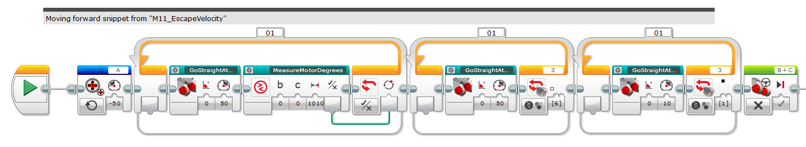

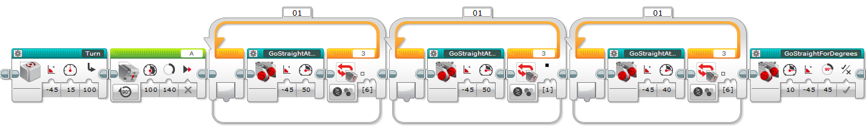

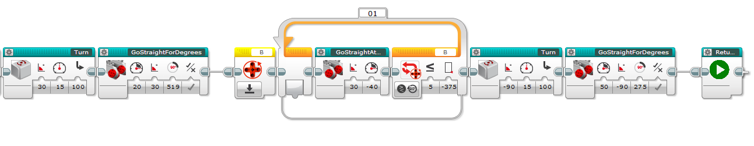

# 10 – M02_SolarPanelArray

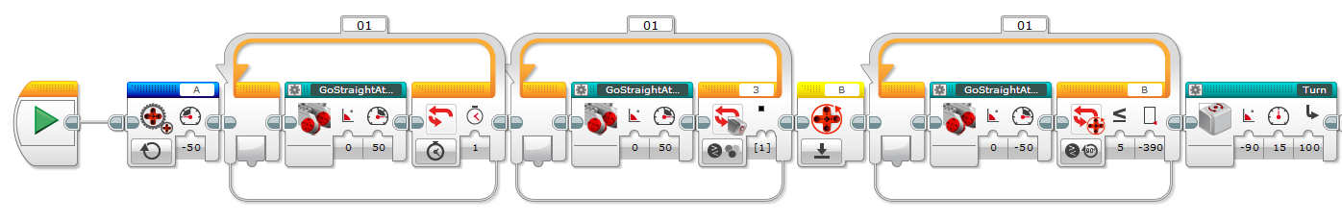

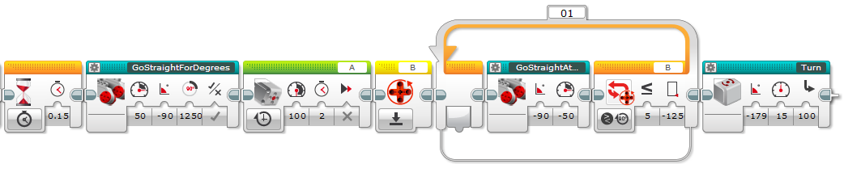

# 11 – M03_3DPrinting

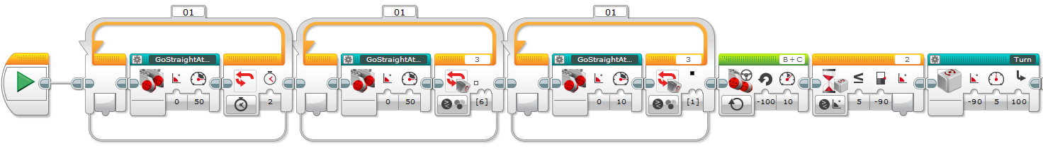



# Victory Dance

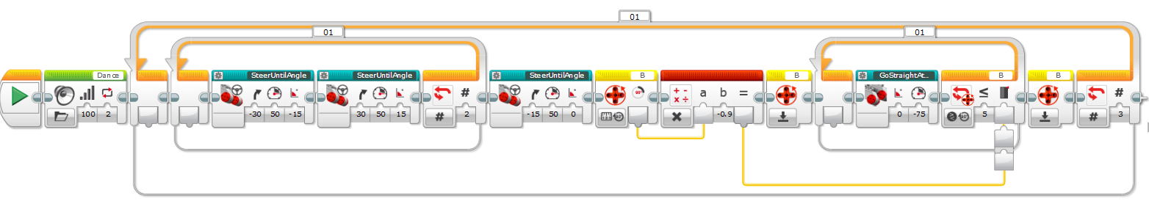

# MENU

